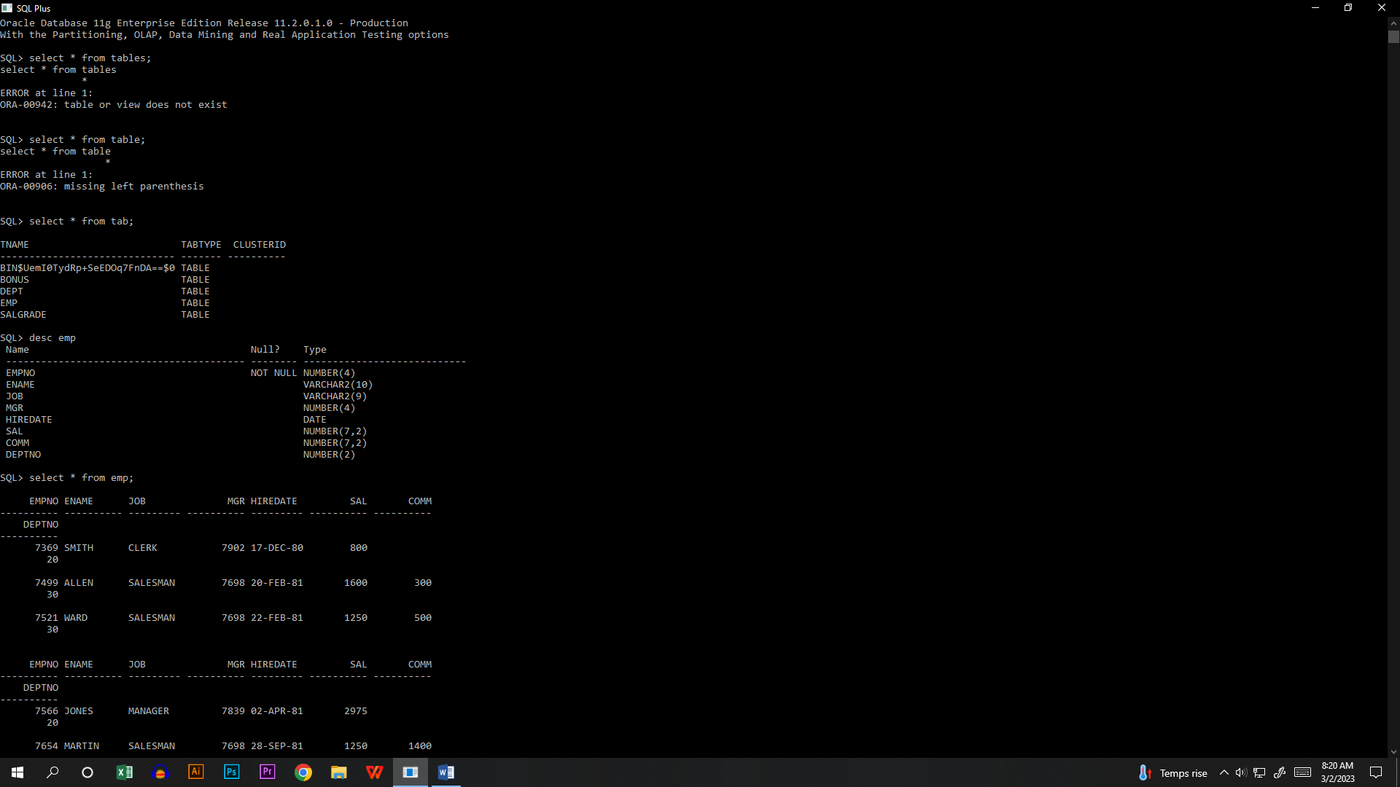

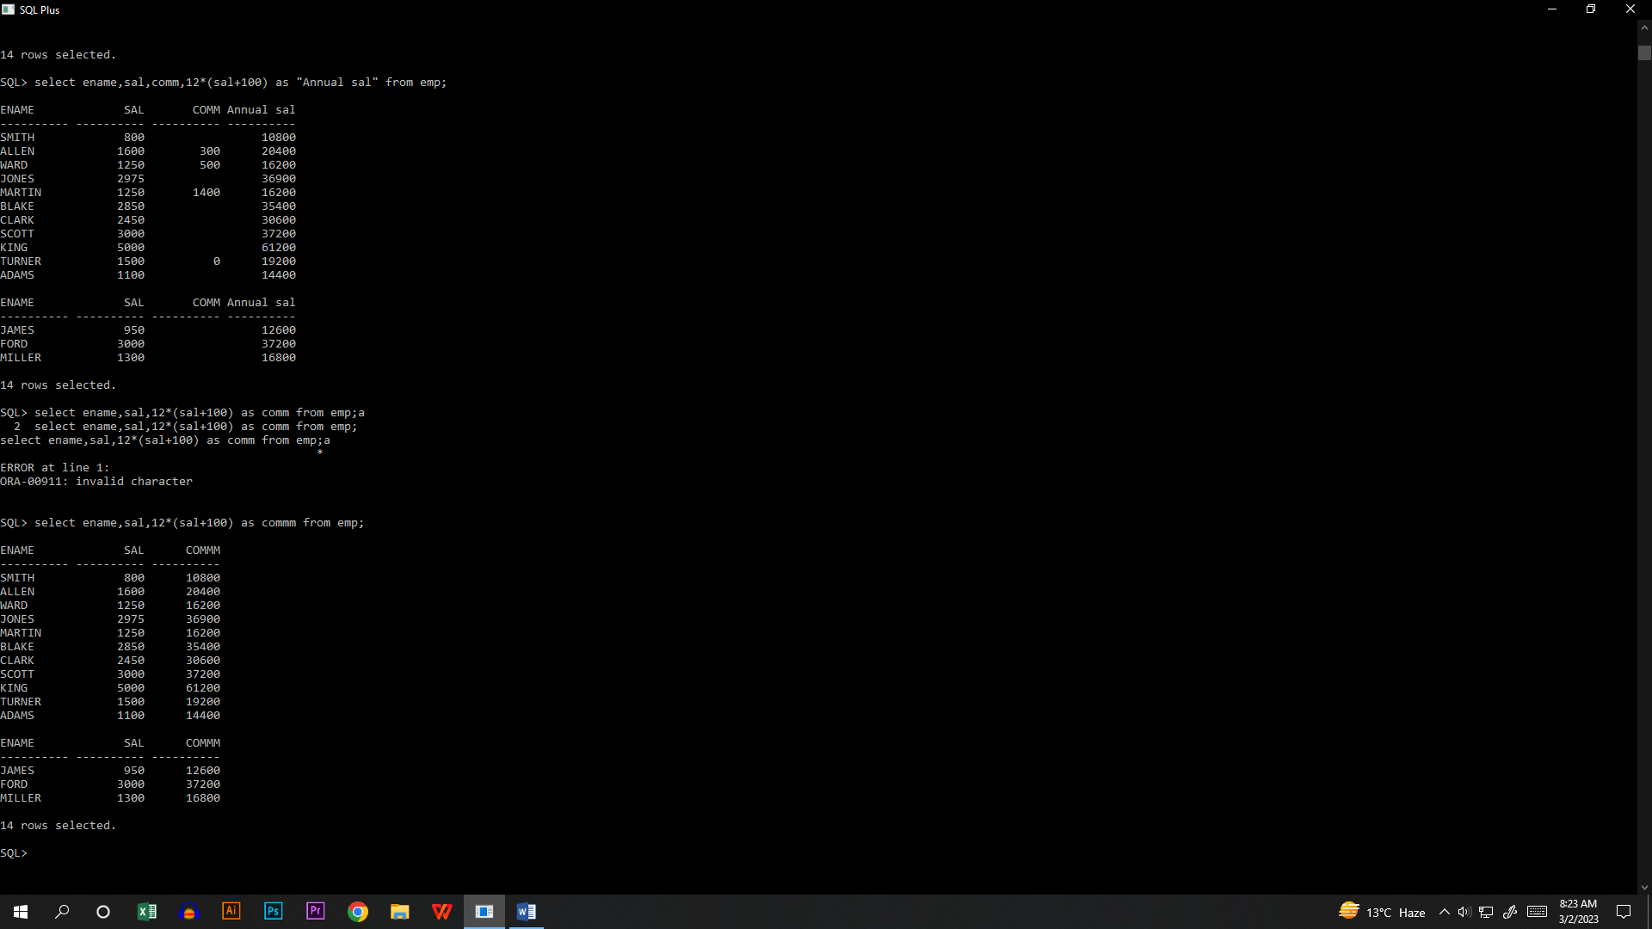

Concatenation operation :

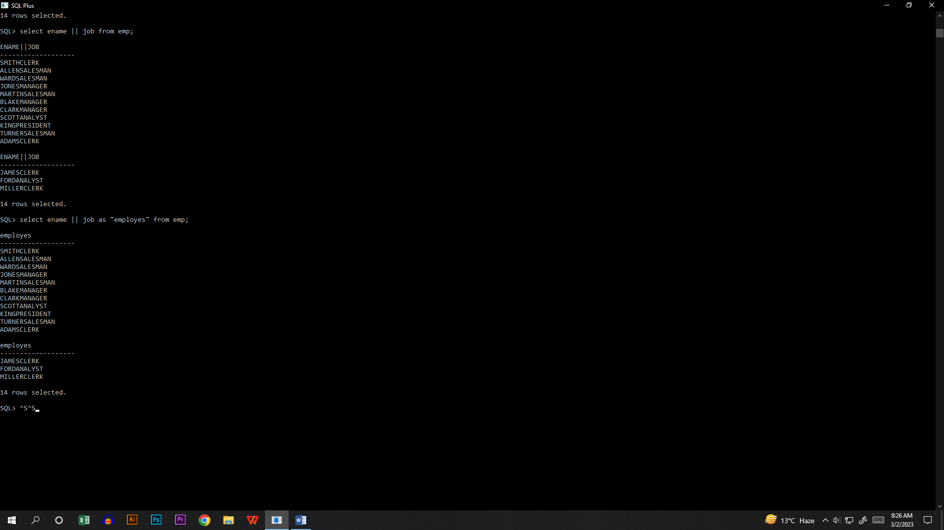

* Literal character:

select ename || '=>' || job AS "employes" from emp;

* Literal character string:

select ename ||': monthly salary = '||sal as " MONTHLY salary" from emp;

* Alternative quote(q)operator:

select dname || q'[department's location = ]' || loc "Department" from dept;

select deptno from emp;

select distinct deptno from emp;

select ename,job,sal*12 " yearly sal" from emp;

select ename||' , ' || job "Employee and title " from emp;

Query 1: select ename EMP_NAME,job EMP_JOB, sal EMP_SALARY from emp;

QUERY 2: select ename|| ',,' ||job||',,'||sal||' '||comm "OVERALL RECORD" from emp;